# woman technologist Day 1: Coding Basics



**WIFI** cowork @ lisboa

**PASSWORD**: 1familiainvicta

# 

# woman technologist Why She Codes?



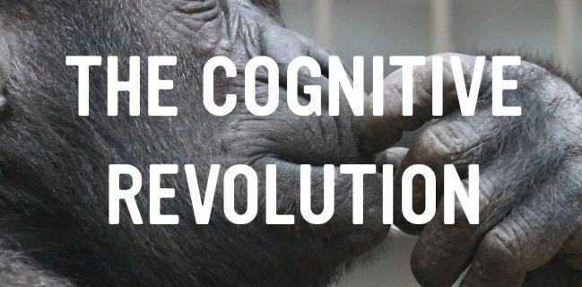

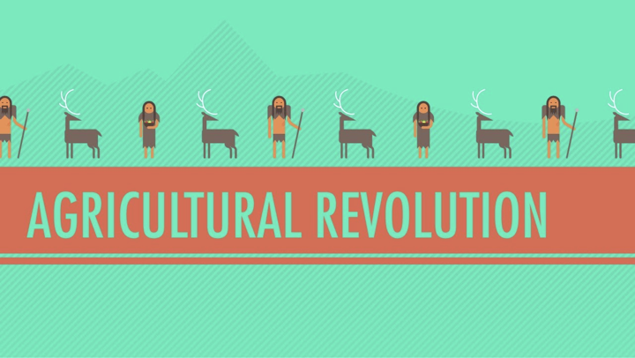

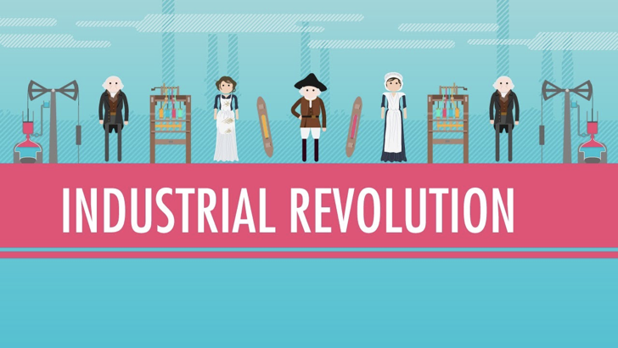



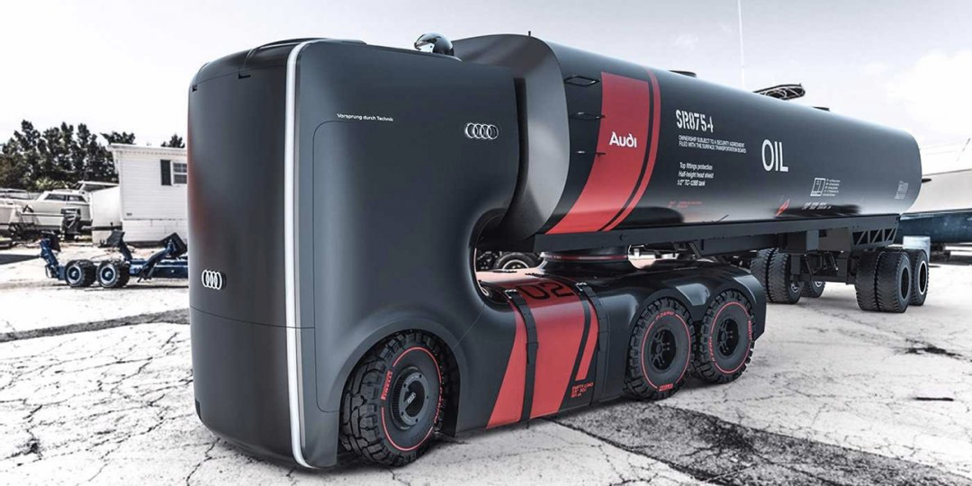



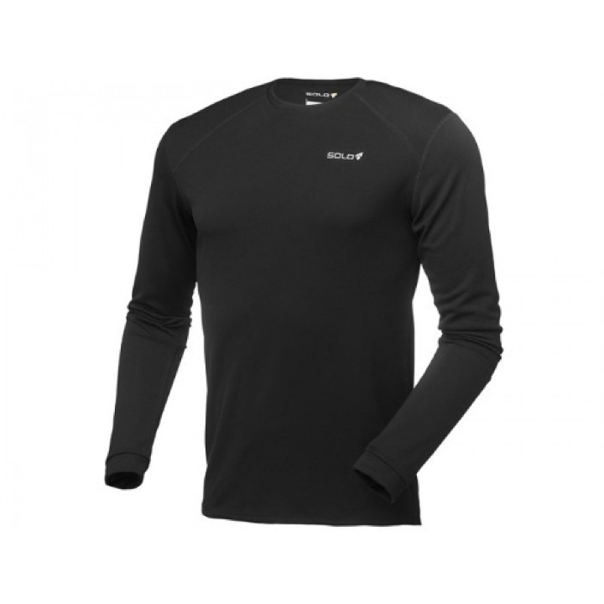

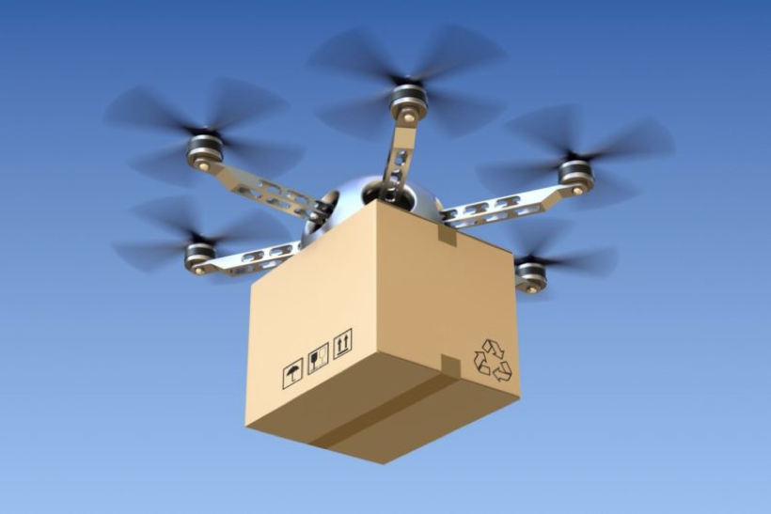

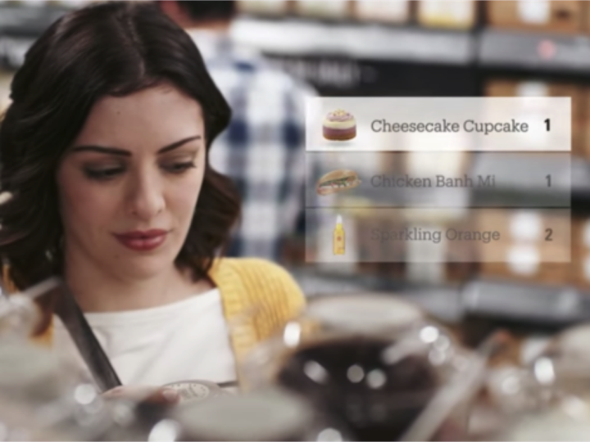



<http://www.sciencemag.org/H6sites/default/files/audio/Magneta-audio.mp3>



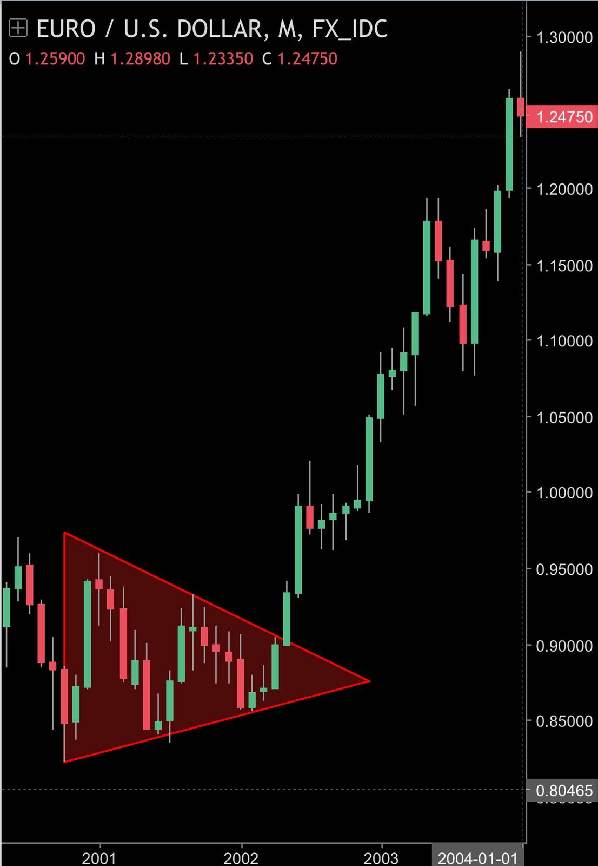

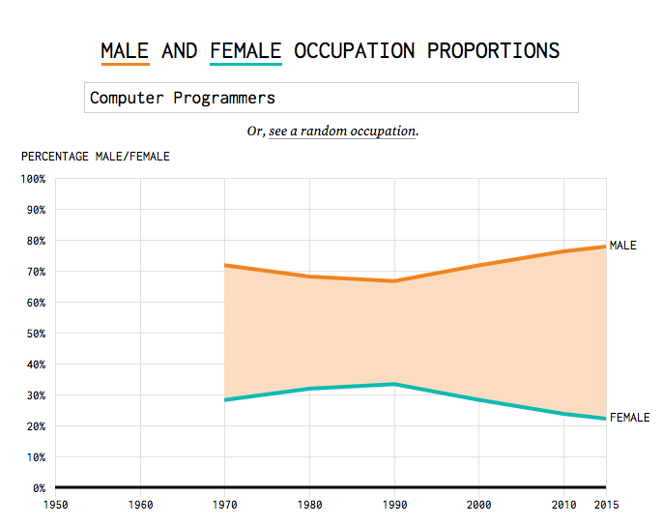

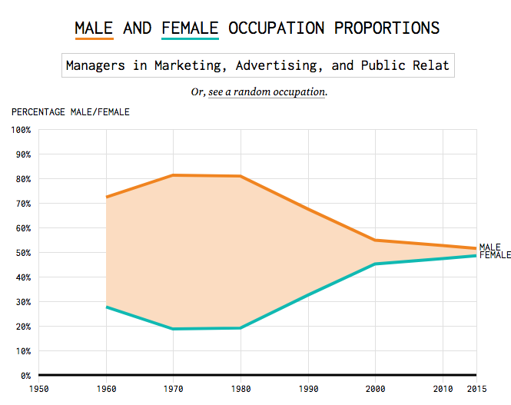

# thinking face What to expect?

## hammer and pick Product Developer

## card index dividers Product Manager

## artist palette Product Designer

# 

# waving hand Who are you?

# hot beveragechocolate bar Isabel

# high voltage Filipa

# airplane Rita

# red heart Sofia

# party popper Catarina

# man lifting weights Elina

# penguin Sandra

# grinning cat face with smiling eyes Maria

# woman dancing Carolina

# heart decoration Ana

# books Deanna

# woman detective Andrea

# face with tears of joy Carla

# smiling face with open mouth Anabela

# winking face Isabel

# grimacing face Sara

# upside-down face Lucilia

# speak-no-evil monkey Catarina

# rolling on the floor laughing Raquel

# person facepalming Daniela

# star-struck Mariana

# person shrugging Joana

# broccoliclinking beer mugs Lea

# unicorn face Nathalia

# fox face Maria

## 

# woman technologist She Codes Team

## Beatriz  / Everything

## Jamie  / Everything

## Luis / Porto i/o Marketing Lead

## Daniela / Operations manager

## Luis / Dev assistant

## Robbie / Dev assistant

## Marissa / Dev assistant

## Rado / Dev assistant

# Who am I?

# France I’m Matt

## hatching chick Full-stack engineer

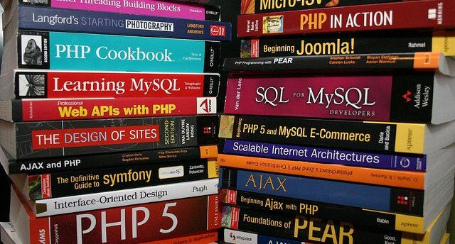

## Uplabs Founder / CEO

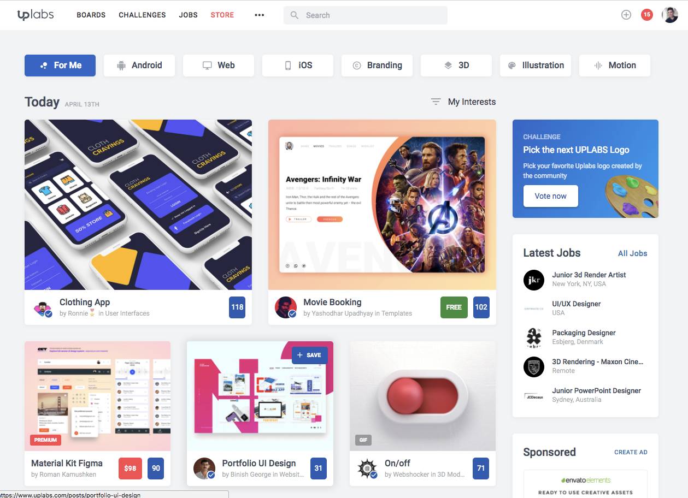

## Y Combinator founder

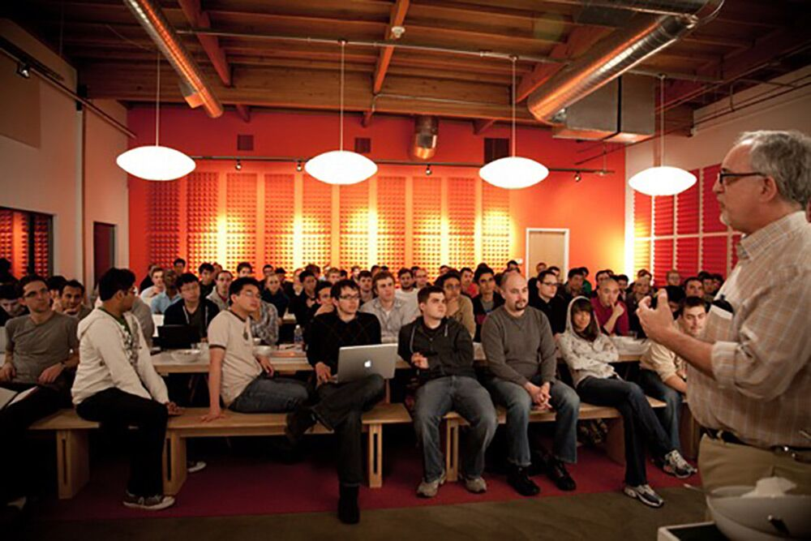



## Worked with these companies



## Open-source contributor

# 

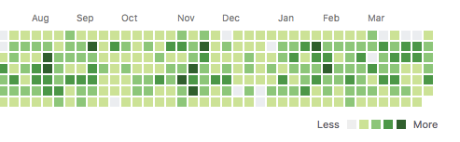

# I have a dream

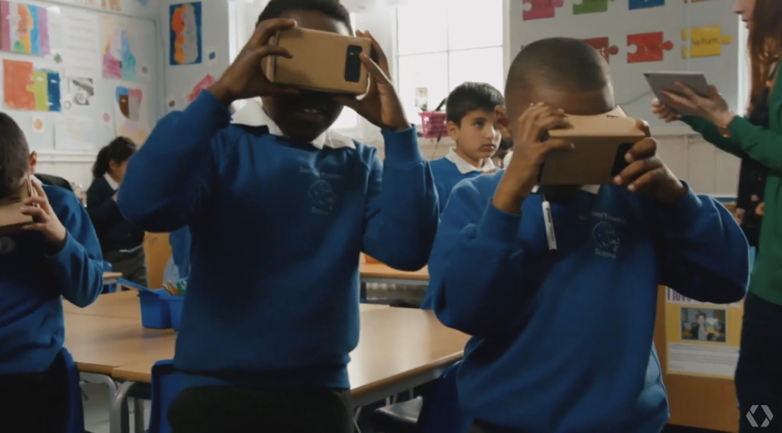

# hear-no-evil monkey Few things before start

## 

## toilet Bathroom

## woman firefighterFire exit

## alarm clock On time

## man in lotus position Breaks

## United Kingdom English or Portugal Portuguese only

## woman technologist Help each other

# chequered flag Let’s begin !



# calendar Workshop program

## Day 1

HTTP / HTML / UI / CSS

## Day 2

JS

## 



## 



# calendar Program of the day

* Development types
* Hello World
* HTTP
* Front-end vs Back-end
* HTML
* UI Design
* CSS
* Wine 

# Development types

## pager Software development

## desktop computer Web development

## mobile phone Mobile development

## 

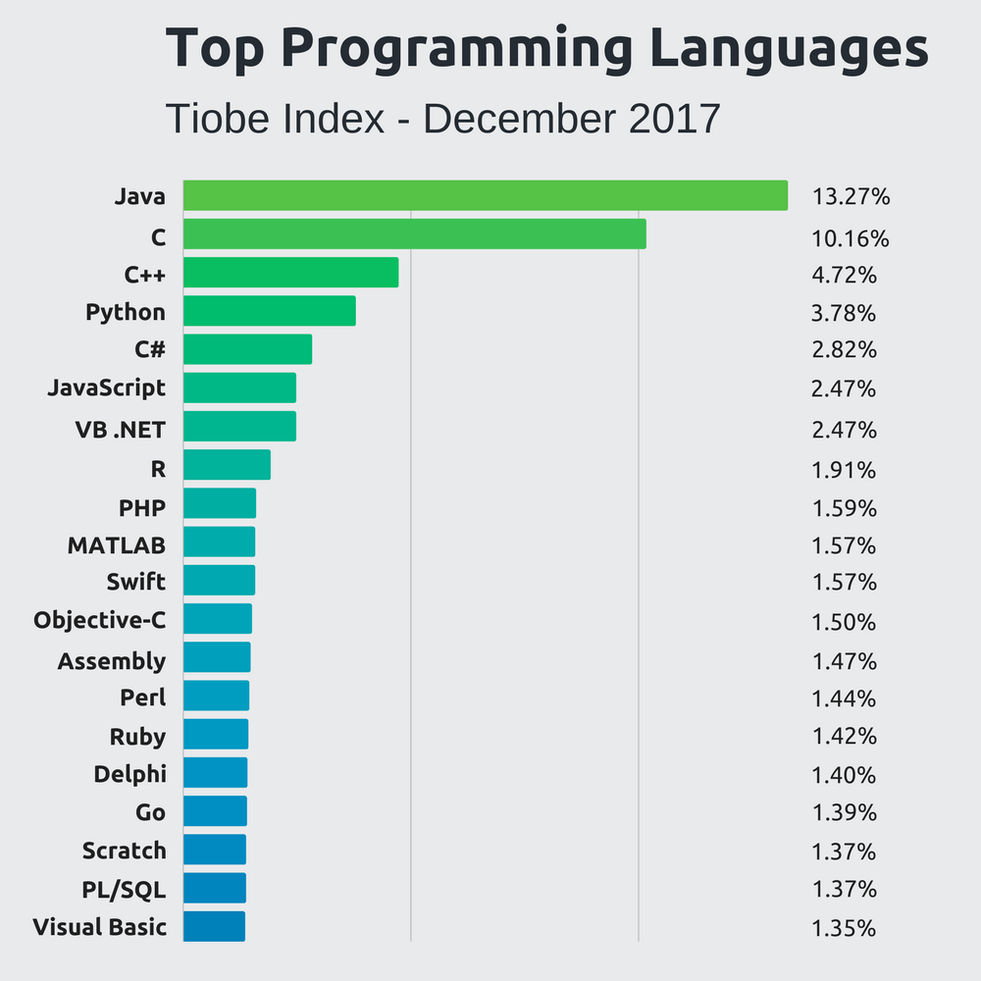

# waving hand  <Hello, World! />



# laptop computer HTTP

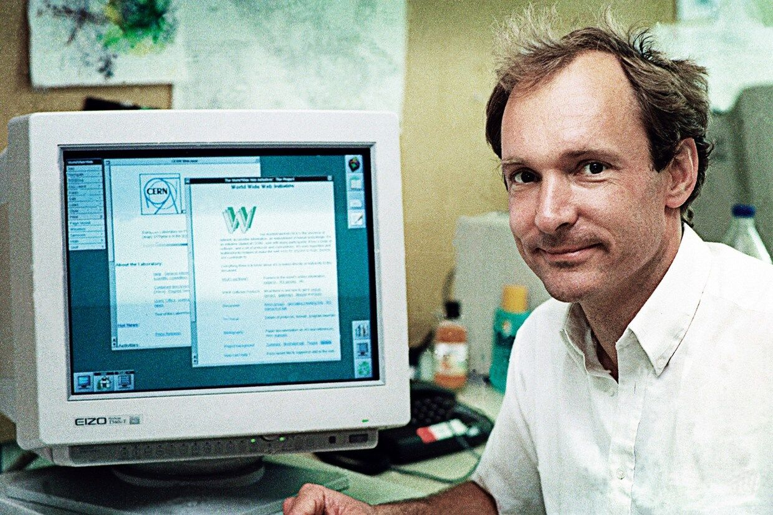





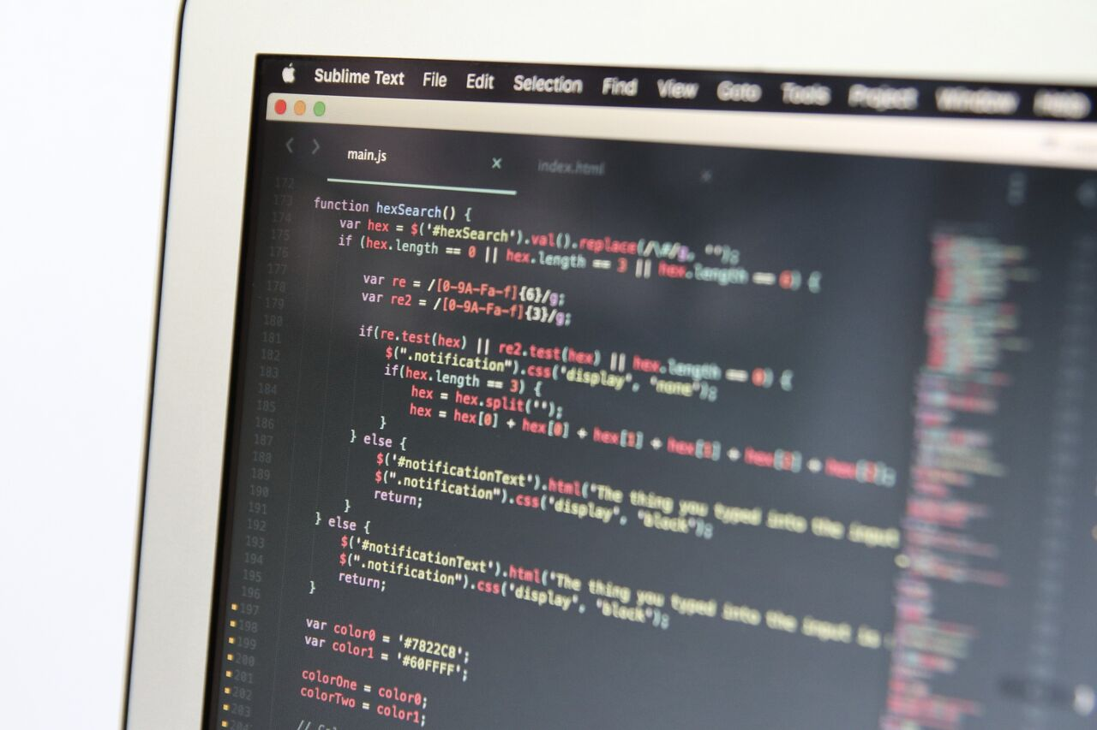

## HyperText Transfer Protocol

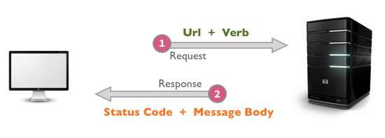

http://www.google.pt/search?q=lisbon

* **scheme**: http
* **authority**: www.google.pt
* **path**: search?q=lisbon

https://www.facebook.com/shecodesio/

* **scheme**:  https
* **authority**: www.facebook.com
* **path**: shecodesio

https://www.fb.com

* **scheme**: https
* **authority**: www.fb.com

## open mailbox with raised flag Response types

image/gif

video/ogg

text/html

text/css

application/javascript

application/json

## Front-end development

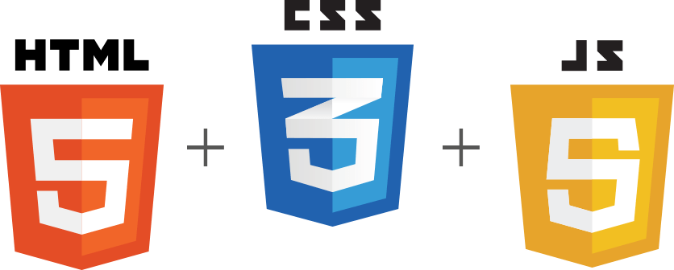

## 

## Back-end development



## 



## HTML fire

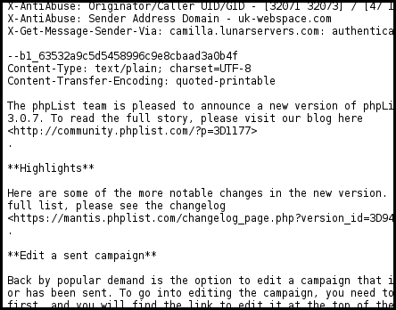

# HTML <Elements />

* Headings

<h1>Title</h1>

<h2>Title</h2>

<h3>Title</h3>

<h4>Title</h4>

<h5>Title</h5>

<h6>Title</h6>

* Paragraphs

<p>

 This is a paragraph

</p>

* Text Styling

<em>this is italic</em>

<strong>this is bold</strong>

* Self closing tags

<br>

<hr>

* List items

<ul>

  <li>Paris</li>

  <li>Lisbon</li>

  <li>Madrid</li>

</ul>

## hammer HTML Exercise 1

Go to <https://codepen.io>, and create this test in HTML:

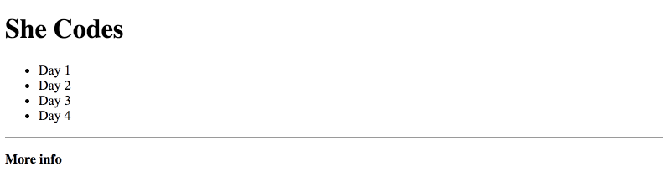

# HTML Attributes

<a href="https://shecodes.io/" target="_blank>

  This is a link

</a>

<img src="http://instagram.com/cat.png" />

## hammer HTML Exercise 2

<https://shecodes.io/day1>

<https://shecodes.io/day2>

<https://shecodes.io/day3>

Link days to <https://shecodes.io/> and add a random image

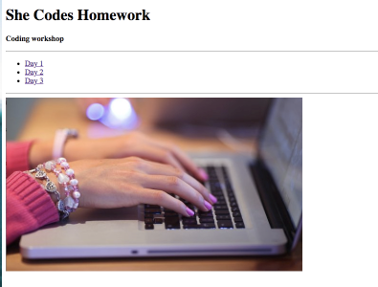

# globe with meridians Browsers

* Inspect elements
* Source page

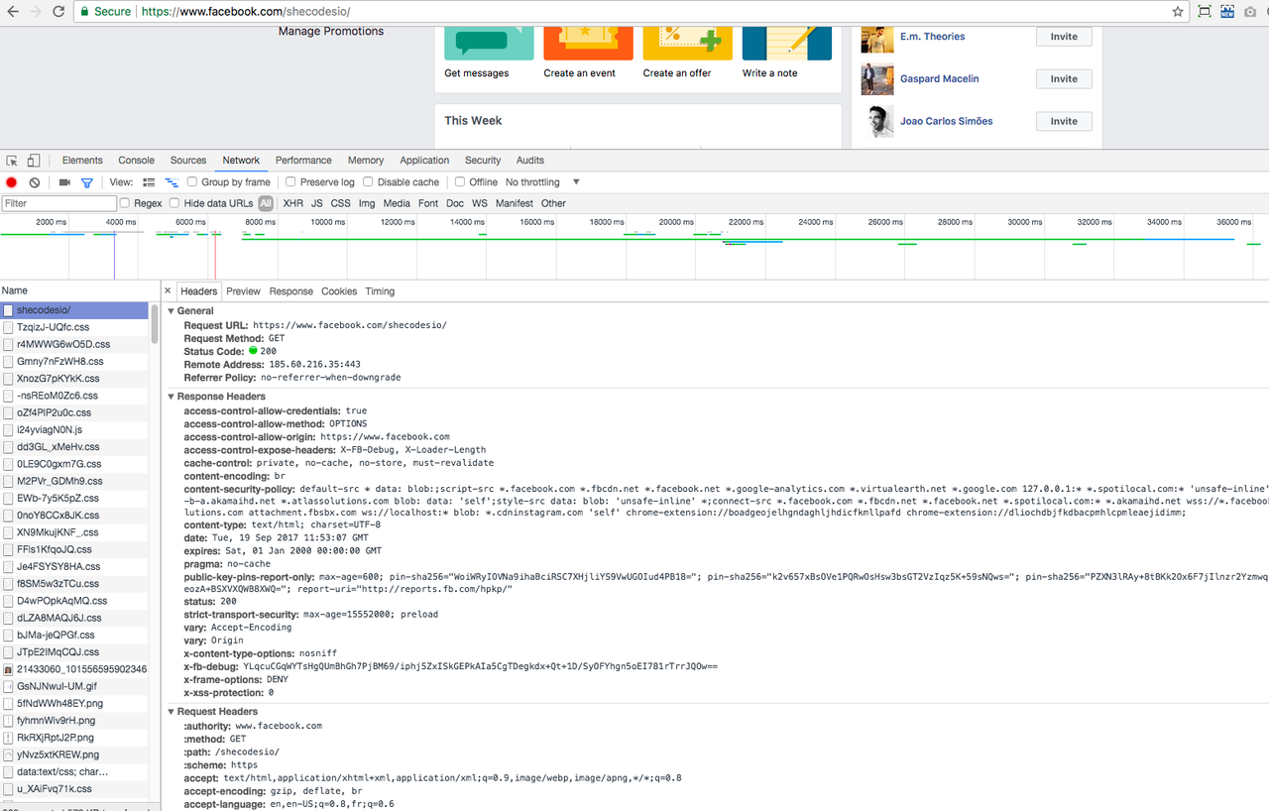

# Let’s CODE!

1. HTML file
2. HTML elements

<html>

  <head>

    <title>Title of the document</title>

  </head>

  <body>

    The content of the document......

  </body>

</html>

## hammer HTML Exercise 3

Move your Codepen exercise into an HTML file and open it in a browser



# woman artist CSS

# Styling

<h1 style="text-decoration: underline"></h1>

## hammer CSS Exercise 1

Underline the heading using inline styles

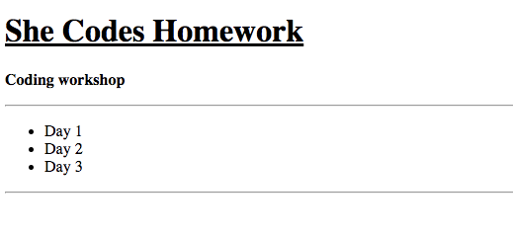

# CSS Selectors

<style>

  h1 {

    text-decoration: underline;

  }

</style>

## hammer CSS Exercise 2

Underline the heading using a CSS selector

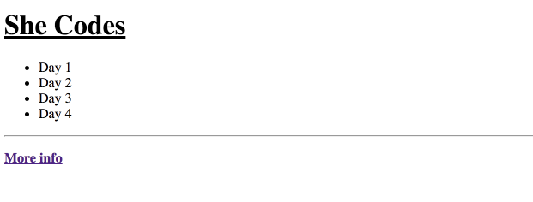

# CSS Properties

  h1 {

    text-align: center;

    font-size: 13px;

    font-weight: 500;

    color: red;

    text-decoration: underline;

    background-color: green;

  }

## hammer CSS Exercise 3

Style your HTML like so

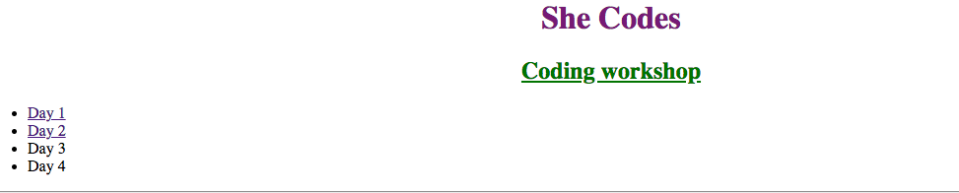

[Style elements using these properties](https://codepen.io/matthieua/pen/JrXqKY)

# Colors

* 1. Pseudo colors

color: red;

color: green;

* 1. HEX

color: #32529f;

* 1. RGBA

# CSS Exercise 3

Title color [#885df1](https://paper.dropbox.com/?q=%23885df1)

Sub header color: [#272044](https://paper.dropbox.com/?q=%23272044)

1. Background color: [#f6f2fe](https://paper.dropbox.com/?q=%23f6f2fe)

color: #885df1;

background-color: #f6f2fe;

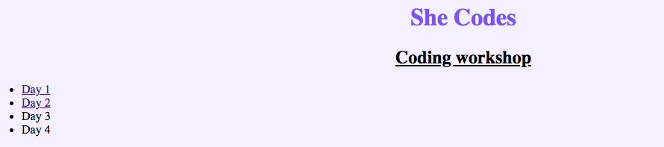

## HTML Generic Elements

<div></div>

<span></span>

## HTML Classes

<ul>

  <li class="europe">

    Paris

  </li>

  <li>

    New York

  </li>

  <li class="europe">

    Lisbon

  </li>

</ul>

a.europe {

  color: blue;

}

# CSS Exercise 4

Target each day with CSS classes and apply different styling

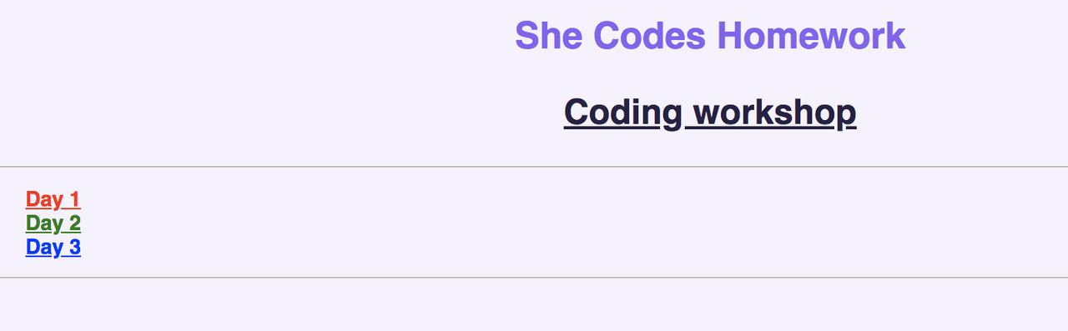

# books Exercise 5

Recreate She Codes header by **Tonight midnight**!

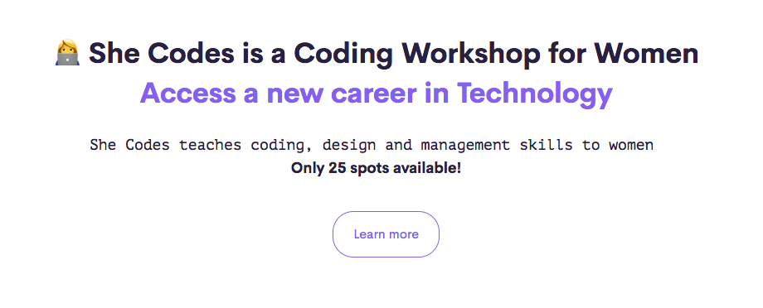

## two women holding hands Let’s work in pairs [#slack](https://paper.dropbox.com/?q=%23slack)

students = ['Isabel PC','Filipa','Rita','Sofia','Catarina C','Elina','Sandra','Maria M','Carolina','Ana','Deanna','Andrea','Carla','Anabela','Isabel P','Sara','Lucilia','Catarina B','Raquel','Daniela','Mariana','Joana','Lea','Nathalia','Maria J', 'Matt']

students.shuffle.each_slice(2).each do |student_one, student_two|

  puts "#{student_one} with #{student_two}"

end

# collision Advanced CSS

## joystick Selectors

a.special

a#very-special {}

a:hover {}

a.special.highlighted {}

.special {}

a, .special {}

li .special {}

## hammer Advanced CSS Exercise 1

Change styling on hover

<https://goo.gl/ax3by1>



## up-down arrow Spacing

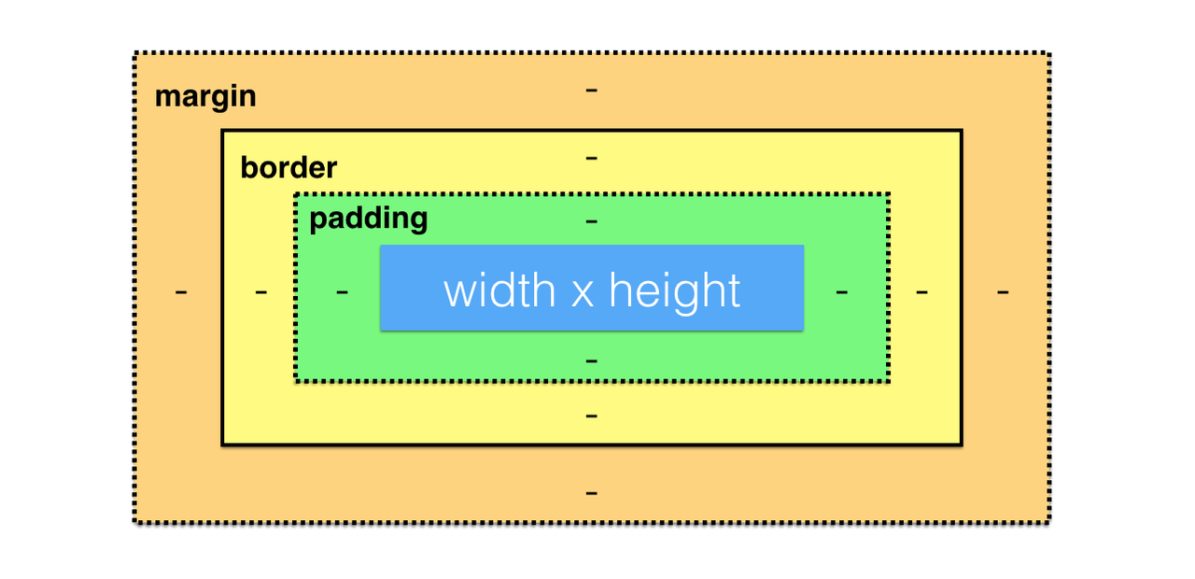

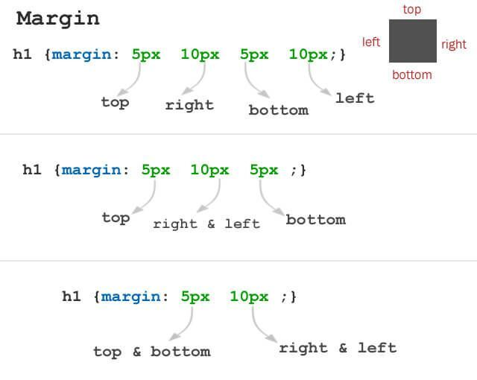



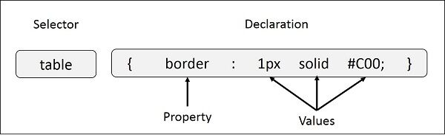

## hammer Advanced CSS Exercise 2

<https://codepen.io/matthieua/pen/YewoNM>

colors:

purple: #885df1

pink: #ef5d98

## blue circle Radius

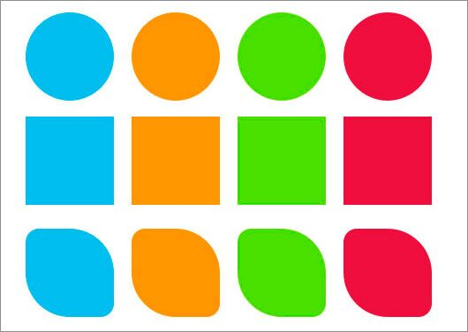

border-radius: 20px;

border-radius: 50% 50% 0 0;

## hammer Advanced CSS Exercise 3

Add rounded corners to the button

## ❑ Shadow

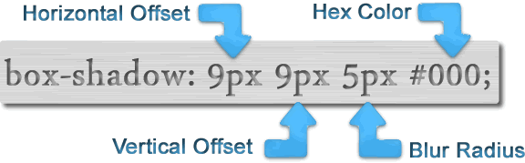

## hammer Advanced CSS Exercise 4

Add some shadow to the button, on hover as well

## droplet Gradient

/* A gradient tilted 45 degrees,

   starting blue and finishing red */

  background: linear-gradient(45deg, blue, red);

## hammer Advanced CSS Exercise 5

Add background gradient to the button from <https://webgradients.com/>

## high-speed train Transitions

a {

  transition:  all 200ms ease;

  opacity: 1;

  color: blue;

}

a:hover {

  opacity: 0.7;

  color: red;

}

|  |  |
| --- | --- |
| linear | The animation has the same speed from start to end |
| ease | Default value. The animation has a slow start, then fast, before it ends slowly |
| ease-in | The animation has a slow start |
| ease-out | The animation has a slow end |
| ease-in-out | The animation has both a slow start and a slow end |
| cubic-bezier(*n*,*n*,*n*,*n*) | <http://easings.net/> |

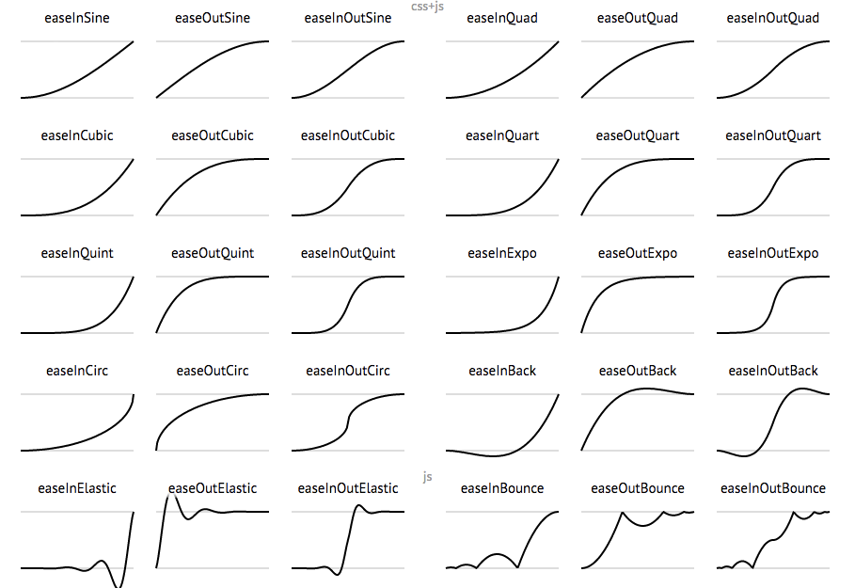

## hammer Advanced CSS Exercise 6

Recreate She Codes section in HTML/CSS



# artist palette Frameworks

## HTML/CSS Frameworks

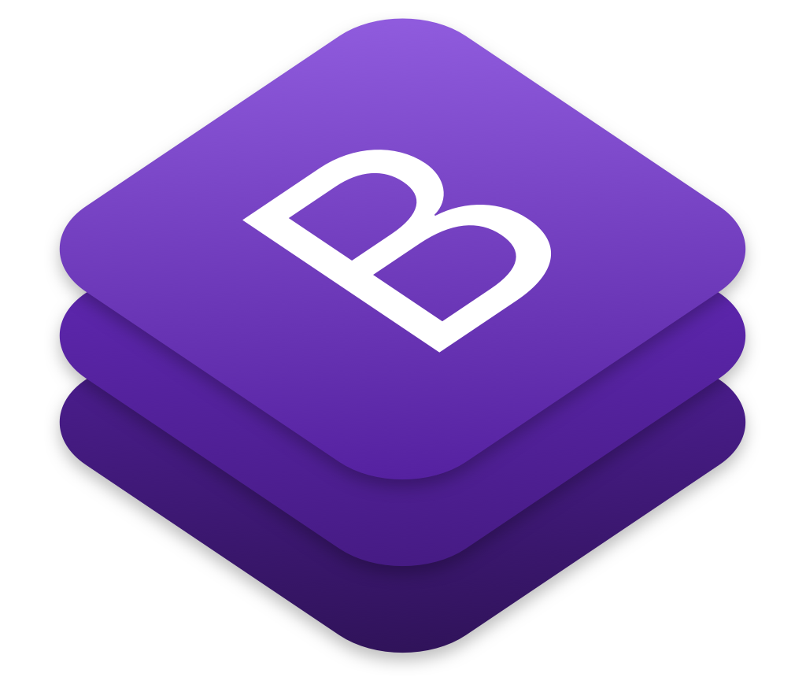

## JavaScript Frameworks



# desktop computer Back-end frameworks



# woman technologist Next She Codes class

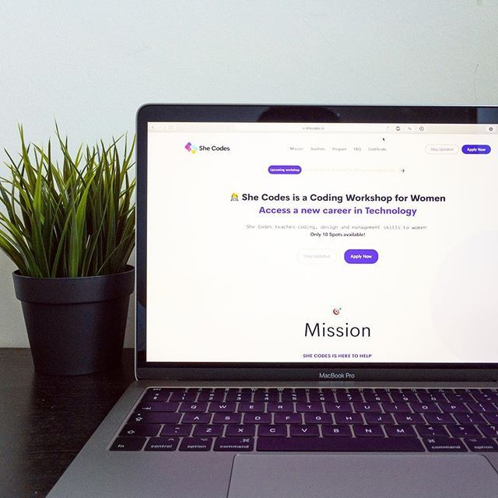

# spiral calendar Tomorrow

JavaScript

Project

—



# graduation cap Graduation details

## NEW button face screaming in fear Final project

## calendar Graduation:  September 15th at 5:30pm,

## wine glass Drinks + Certificate

## world map Letraria Craft Beer Garden Porto

## 

